**Quick Guide**

1. Read about Version control systems: <https://git-scm.com/book/en/v2/Getting-Started-About-Version-Control>
2. Install GIT by link: <https://git-scm.com/download/win>
3. Install Tortoise GIT(GUI-client) by link: <https://tortoisegit.org/download/>

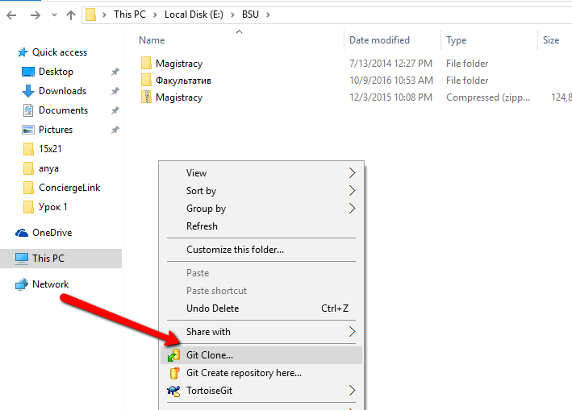

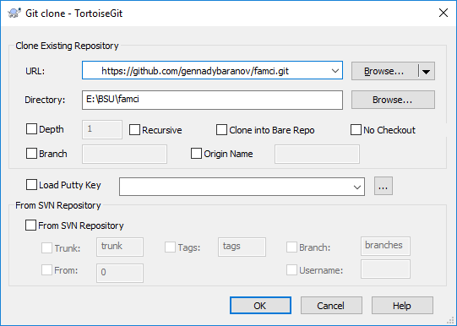

(<https://github.com/gennadybaranov/famci.git>)

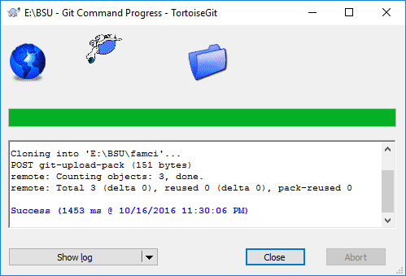

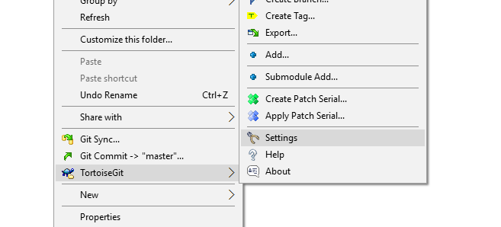

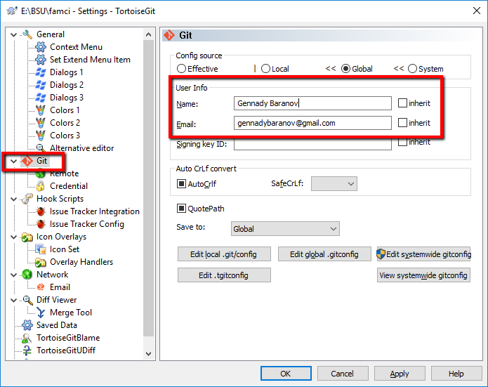

Please add the folder with your name-surname to the folder Task1 with completed task. 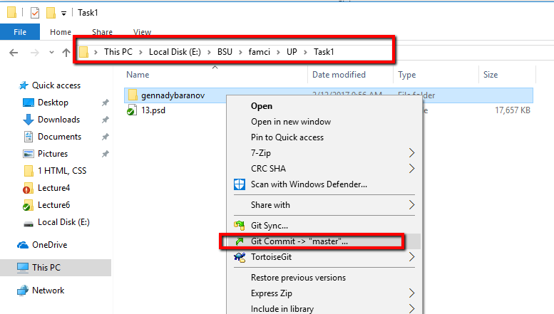

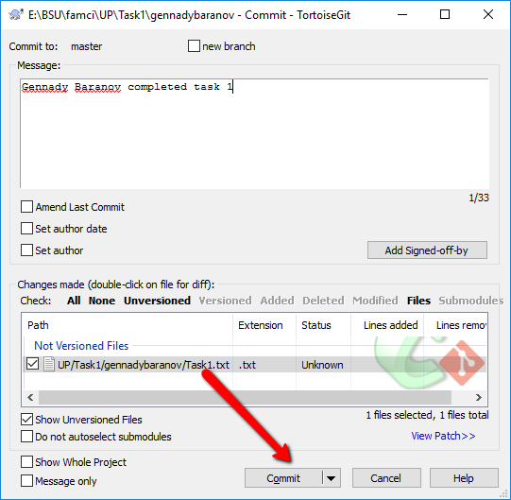

And push your changes to the server:

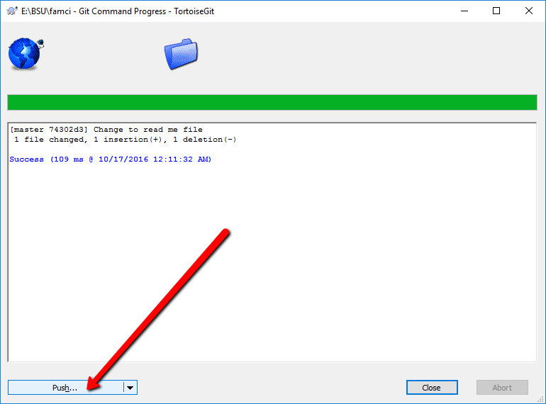

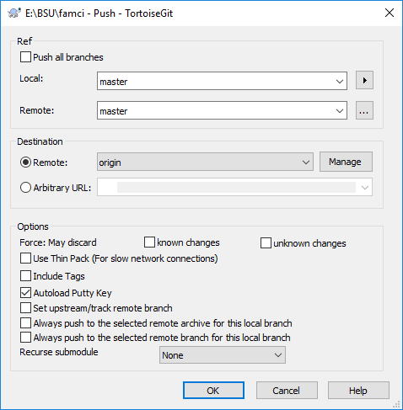

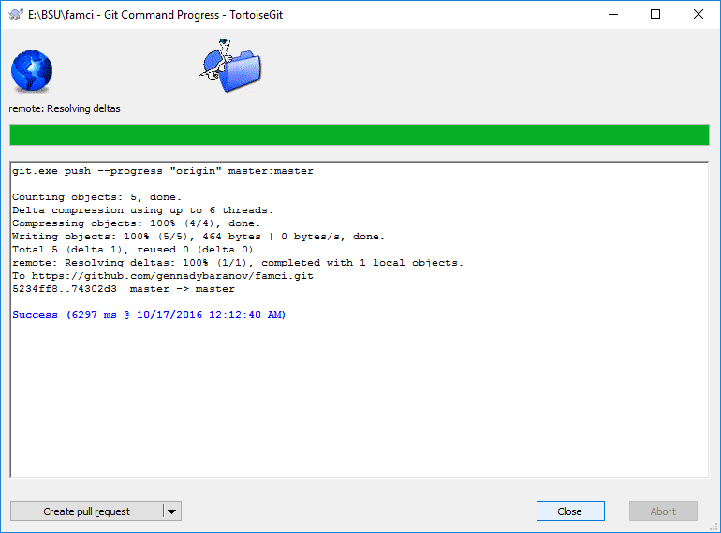

Go to <https://github.com/gennadybaranov/famci/tree/master/UP/Task1> and check that new folder with your name and surname was added:

